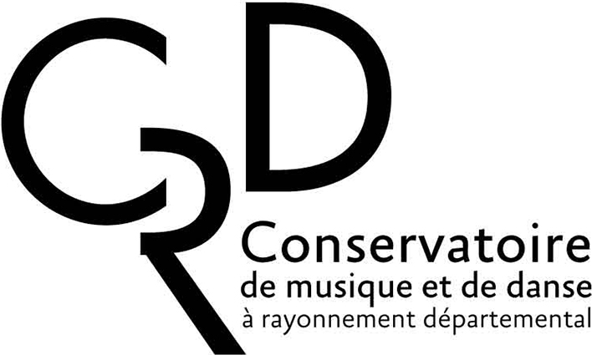 | CONSERVATOIRE DE MUSIQUE ET DE DANSE A RAYONNEMENT DEPARTEMENTAL  REGISTRATION FORM TO THE  ENTRANCE EXAMINATION 2022/2023

Last name :  First name :  Disciplin : | Staple two photos here
Please write in capital letters. All fields are required
Please email, post or fax fully completed form till seven days before the audition.
Incomplete or belated applications will be rejected.
MAJOR DISCIPLIN
- Musical or choreography disciplin :
Compulsory medical certificate for dance must be included in the documentation
Complementary desired disciplin :
Music theory (specify you level) :
Musical history Analysis Harmony and Counterpoint
Composition Piano accompaniment Orchestra conducting
Vocal art Other :
LEVEL OF APPLICATION (please tick relevant box)
First cycle  Second cycle  Third cycle (CFEM) | Postgraduate education :
First cycle  Second cycle  Third cycle (CFEM) | DEM
First cycle  Second cycle  Third cycle (CFEM) | Perfectionnement
First cycle  Second cycle  Third cycle (CFEM) | Your choice for a teacher :  Would you accept another teacher?  no  yes (specify the name)

APPLICANT
Last name : | First name :
Date of birth : | Place of birth :
Address :

Postal code - City : | Phone number :
Cell or international phone number : | e-mail :
Citizenship :

❑ French  E.U. country. (specify) :  other (specify) :

Parents’ profession :  Father :  Mother : | Student’s profession :

UNDERAGE APPLICANTS
Last name-First name of legally responsible person:

Address : (if differing)

Phone/cell phone number : | Professional phone number :
e-mail :

Contact person in case of emergency (if differing)

Phone number :

FORMER MUSICAL, CHOREOGRAPHIC, ACADEMIC or UNIVERSITY EDUCATION (Specify highest achieved level of education)
 | School (s) | Year | Achieved level  (copy of all certificates related to artistic education) | Awards  (to be specified + copy of diplomas in music/dance)
Main artistic disciplin (Major):

Music theory :

Any claim for exemption should be specified: in which case please enclose certificates or attests of the corresponding diplomas.
Other disciplins :
(specify) :

Secondary or university education

ACADEMIC or UNIVERSITY EDUCATION intended for the coming year
School / University | Training course | Post baccalaureate level
To be filled in only when applying for DEM or postgraduate education
Reasons for your application:
Preparing entrance examination to the C.N.S.M.
Preparing entrance examination to the C.E.F.E.D.E.M. or C.F.M.I
Preparing entrance examination to a position in an orchestra
Preparing international competition
Other (Specify) :
Are you professionally active ?
Yes No
If yes, in which field ? :
1 I hereby commit myself to acquaint with and follow all the internal rules in the Conservatoire (please consult the corresponding notice board on display at the Conservatoire).
2. I hereby commit myself to take out a casualty insurance covering all damages. The Conservatoire has no legal obligation to any supervision except that of classes.
3. I hereby commit myself, after my admission:
- to pay the registration and tuition fees to the CRD of Aulnay-sous-Bois within three days following my admission. Registration fees are not refundable. Payment can be made quarterly.
- not to register in any another music educational establishment in the same courses
- to attend, as part of my educational tuition, three concerts or performances organized by the Conservatoire or made in partnership with the Conservatoire. My attendance to three such performances will be validated by means of three stamps (one for each performance) on my student card.
Third Cycle Students (Postgraduate students):
I hereby commit myself to:
- register in all disciplins for the DEM including chamber music, a compulsory disciplin to obtain the diploma.
- to subscribe to the Social Security for Students on the day I register at the CRD.
- to participate in at least one ‘Carte Blanche’.
- to participate in all complementary activities related to academic or university education, notably the two one-week orchestral sessions to which I will be called. I am aware that any absence during the orchestral sessions, be it a performance or a rehearsal, will be considered as resignation on my part.
Should I register in an incomplete curriculum and/or should I refuse to subscribe to the Social Security for Students, I am aware that I shall not gain student status.
Prospective foreign students must understand French, they may have to take a language test after the instrumental entrance examination.

Date : Applicant’s signature :
(Parents’ signature in case of underage applicant)
(Please write Last name-First name)

(écrire Nom-Prénom
Checklist of supporting documentation :
•All applicants:
- 2 passport photographs
- proof of residence (copy)
- transcripts showing examinations passed
- copy of the achieved results in 2021/2022
•Applicants in dance:
- medical certificate to hand to the teacher
•Foreign applicants:
- copy of valid passport
- copy of visa (if you already have one)
•Postgraduate and proficiency course students:
- curriculum vitae containing relevant data of previous education and musical activities.

